Code:

start_location = input("Enter starting location: ")

destination = input("Enter destination: ")

mode_of_transport = input("Enter mode of transport (Bus, Car, Motorcycle, or Bicycle): ").strip().capitalize()

if mode_of_transport not in {"Bus", "Car", "Motorcycle", "Bicycle"}:

raise ValueError("Error: Invalid mode of transport. Please enter Bus, Car, Motorcycle, or Bicycle.")

try:

distance_input = input("Enter distance (km): ")

if not distance_input.replace('.', '', 1).isdigit():

raise ValueError("Error: Distance must be a numeric value.")

distance = float(distance_input)

if distance <= 0:

raise ValueError("Error: Distance must be a positive number.")

speed_input = input("Enter speed (km/h): ")

if not speed_input.replace('.', '', 1).isdigit():

raise ValueError("Error: Speed must be a numeric value.")

speed = float(speed_input)

if speed <= 0:

raise ValueError("Error: Speed must be a positive number.")

except ValueError as e:

print(e)

travel_time = distance / speed

long_trip = travel_time > 5

print("\nTravel Details:")

print(f"Starting Location: {start_location}")

print(f"Destination: {destination}")

print(f"Mode of Transport: {mode_of_transport}")

print(f"Distance: {distance} km")

print(f"Speed: {speed} km/h")

print(f"Estimated Travel Time: {travel_time:.2f} hours")

if long_trip:

print("Warning: Your trip is longer than 5 hours. A rest stop is recommended.")

else:

print("No rest stop is needed.")

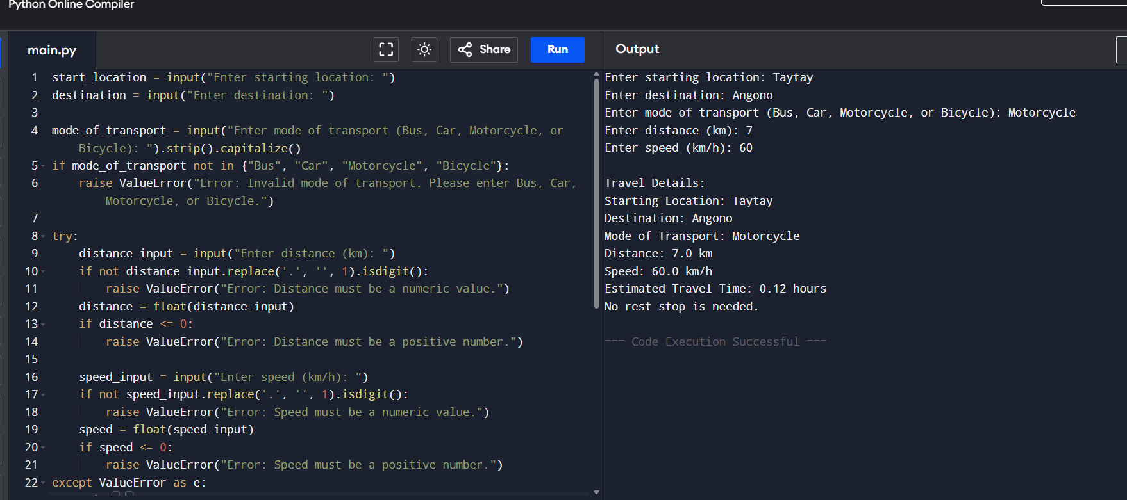**Successful Program:**

Error Handling:  
**Destination –**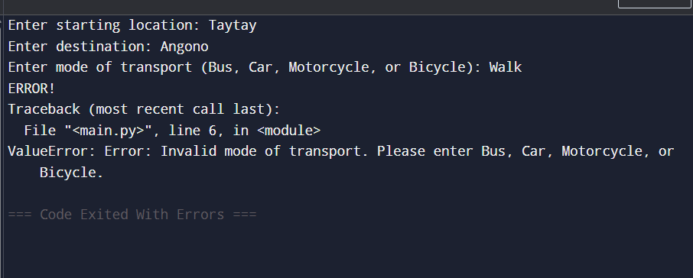

**Distance Numeric –**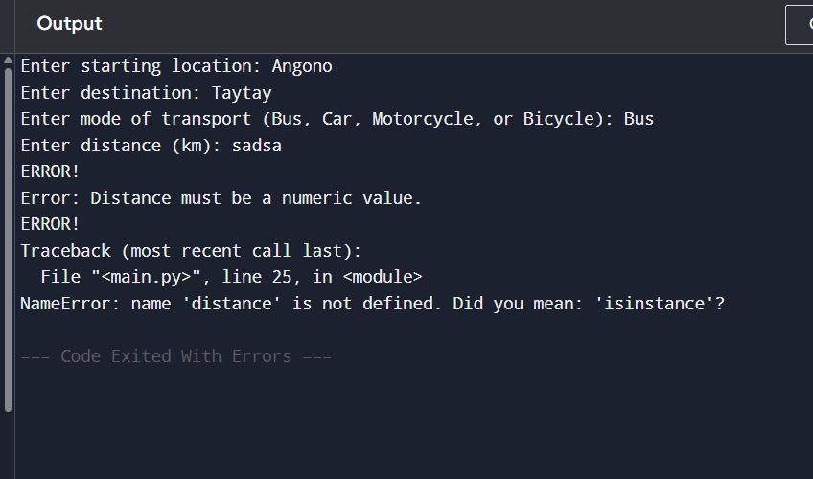

**Speed Numeric –**

